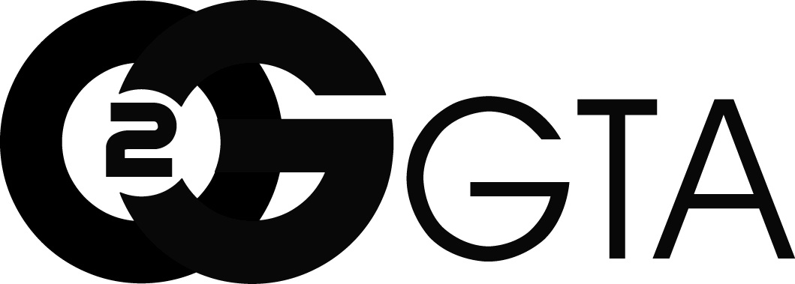
Go 2 Talent Agency, Inc.
2817 W. Magnolia Blvd., Suite A
Burbank, CA 91505
818-843-9800

Amanda Carr
SAG-AFTRA
HEIGHT: 5’3’’ EYE COLOR: Blue HAIR: Blonde

FILM
ZOMBEO AND JULIECULA DANCER CHOR: NATHAN PREVOST
ICHOOSE VIDEO DANCER CHOR: JOE MALONE

TELEVISION
YOUNG SHELDON COWGIRL #2 CHOR: MICHELLE ELKIN
THE LEAGUE BOLLYWOOD DANCER CHOR: PRAGATI GUPTA
BEST FRIENDS WHENEVER FEATURED DISNEY CHANNEL
CAMP WHATTABUNCHAPHUN DANCER CHOR: ALISON BRETCHES
UNITED STATES OF TARA DANCER

THEATER
THE WIZARD OF OZ ASSISTANT CHOR. CHOR: BILL BURNS
BEAUTY AND THE BEAST ENSEMBLE CHOR: CHERYL BAXTER, DIR: YVETTE LAWRENCE
THE HUNCHBACK OF NOTRE DAME ASSISTANT CHOR. CHOR:MICHELLE ELKIN, DIR: MISTI WILLS
SISTER ACT THE MUSICAL DANCERDANCE CAPTAIN CHOR: MICHELLE ELKIN, DIR: MISTI WILLS
BENCHES TOMMY DIR: JOE MALONE
OKLAHOMA- CABRILLO MUSIC THEATRE DANCER CHOR: JOHN CHARRON
BYE BYE BIRDIE- CABRILLO MUSIC THEATRE DANCER/SAD GIRL CHOR: JOHN CHARRON

MUSIC VIDEO
CLAUDIA COONEY “STAY THE NIGHT” DANCER CHOR: MICHELE SOULCHILD, HAVIC

STAGE/LIVE PERFORMANCE

STRANGER THINGS DRIVE INTO EXPERIENCE CHEERLEADER NETFLIX, FEVER, SECRET CINEMA
FROST AT SIX FLAGS GREAT ADVENTURE DANCER SHADE ENTERTAINMENT
UNLEASHED AT SIX FLAGS GREAT ADVENTURE DANCER SHADE ENTERTAINMENT
BEACH BELLES DANCER AMAX ENTERTAINMENT
TWINKLE TIME AND FRIENDS DANCER TWINKLE TIME AND FRIENDS
CHILL AT THE QUEEN MARY DANCER AMAX ENTERTAINMENT
LES DOLLS DANCER DOLLHOUSE ENTERTAINMENT
KWERK SWING/DANCE CAPTAIN CHOR: ADOLFO BARRETO, EDMAR BENITEZ
FULL THROTTLE NIGHTS SWING/DANCE CAPTAIN CHOR: ADOLFO BARRETO, EDMAR BENITEZ
ELIXIR DANCER ELIXIR THE SHOW
LAST BITCH STANDING BACK UP DANCER CHOR: CALYPSO JETE
VOODOO NIGHTS DANCER CHOR: ADOLFO BARRETO, EDMAR BENITEZ
CHOREOGRAPHER’S CARNIVAL DANCER CHOR: JOE MALONE
HASEEN DANCE COMPANY BOLLYWOOD DANCER DIR: PRAGATI GUPTA
IT’S ALL ABOUT THE LOVE DANCER CHOR: TERRI YATES, LINDSEY LORENZ,
GROOVE THEORY DANCER DIR: DONYELLE JONES AND DASHA TERTOVA
ALL CRACKED UP DANCER DIR: TRACY SILVER AND MARINA BENEDICT
DANIEL PEARL WORLD MUSIC DAY DANCER CHOR: TERRI YATES
ACFCLA- GAIA DANCER CHOR:ANACIA WEISKITTEL

OTHER
STILETTO ENTERTAINMENT SKETCH GROUP DANCER CHOR: JOHN CHARRON/JILL HILLIER

TRAINING
DANCE: JOSEPH MALONE, MICHELLE ELKIN, TERRANCE YATES, JILLIAN SCHMITZ, JACKIE EVANS, IRENE CHO, NANCY DOBBS, MARK GOODMAN, ROMAN VASQUEZ, STEFAN RAULSTON, GUSTAVO VARGAS, NATHAN PREVOST CHRYSSIE WHITEHEAD, TRACY SILVER, JON ENGSTROM, LISA HOPKINS, JUSTINE MENTER, AMANDA WELLS
VOICE: CHRISTINA SAFFRAN
SPECIAL SKILLS
PROFESSIONAL DANCER (BALLET, TAP, JAZZ, HIP HOP), SALSA, PARTNERING, POINTE, FLYING WITH ZFX, MAGICIAN’S ASSISTANT, BOLLYWOOD DANCE

